Algebra 1: Unit 6, Lesson 4

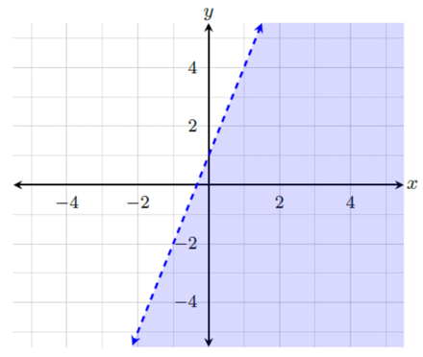
- An inequality and its graph are shown.
$$y<3x+1$$
The point $(0,0)$is in the shaded region of the graph, therefore it _______ in the solution set of the inequality.
is

- The graph of an inequality is shown.
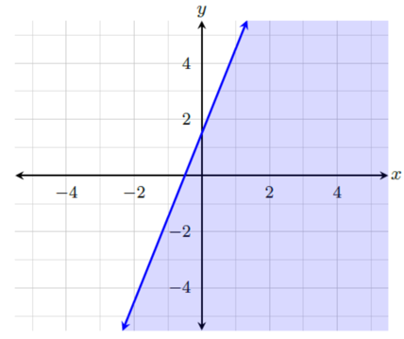
The boundary line of the graph is solid, therefore the points on the boundary line are included in the solution set. If $m$ and $b$ are both positive, what inequality can be represented by the graph?
$$y≤mx+b$$

- An inequality is shown.
$$y>x$$Complete the following statements.
The inequality means that the relationship between the values of $x$ and $y$is that all the solutions will have an $x$-value that is ______________ the $y$-value.
Less than

